Gary Atlin's mail of 8 MAY

Hi Hans-Peter,

I was really struck by the size of the GxL variance for Boro. I was not expecting this. Can we look at the correlations of genotypic effects (or means) among sites? I am still resisting the idea that there is specific adaptation to favorable boro sites in Bangladesh, but we need to check.

Best,
Gary

Size of VC
Based on the models
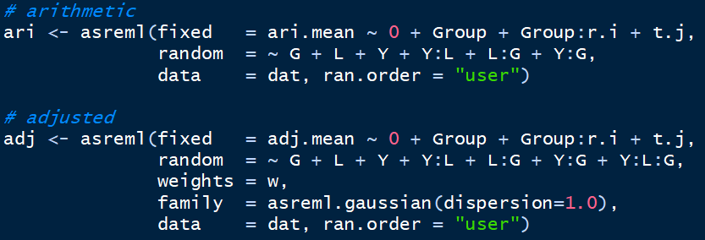

We finde the following variance components (ari left, adj right; aman top, boro bottom):
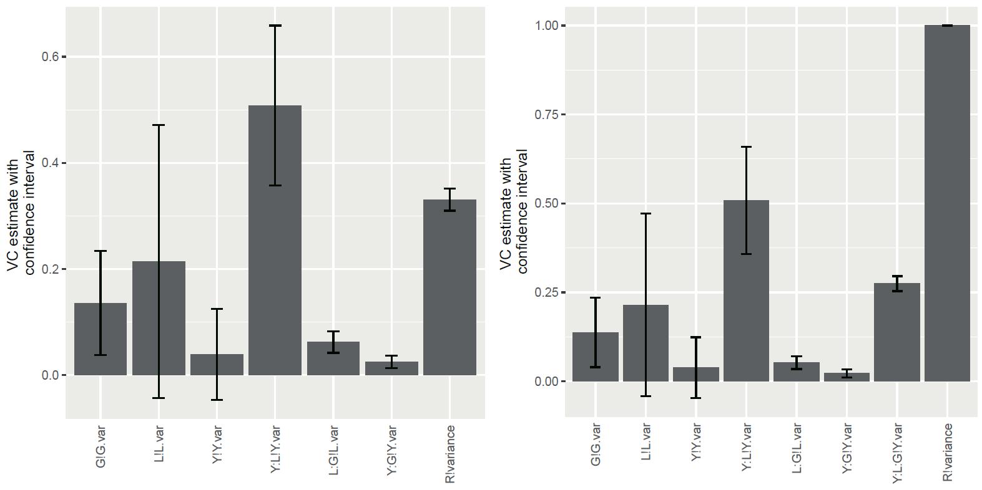

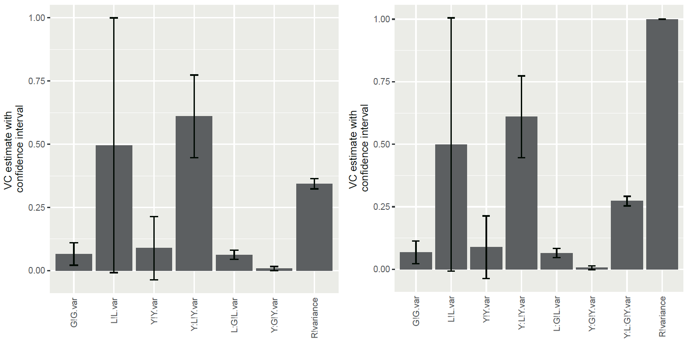

Approach

The genetic correlation is related to effects gen and gen:loc. Under a simple variance-components model, all environments have the same "genetic" variance, i.e. var(gen) + var(gen:loc), and the same covariance, i.e. var(gen). This amounts to the compound symmetry structure, which has genetic correlation of var(gen) ( [ var(gen) + var(gen:loc) ] for all pairs of locations.

This can be generalized and made more flexible. The most complex model is to drop the genotype main effect and fit an unstructured model. I suppose in ASReml this would be something like

random=~us(loc):id(gen)

Based on the following models we find:
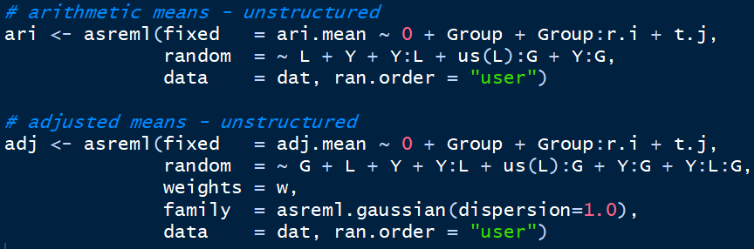

 | Arithmetic means | Adjusted means
Aman | Not converged | Not converged
Boro | Not converged | Not converged

Or we use an FA model instead, making a choice regarding the number of multiplicative terms, e.g. three:

random=~fa(loc,3):id(gen)

From these fit, we should be able to extract the 10 x 10 genetic correlation matrix between locations. If the US model works, it's simplest to just use that.

Based on the following models we find:
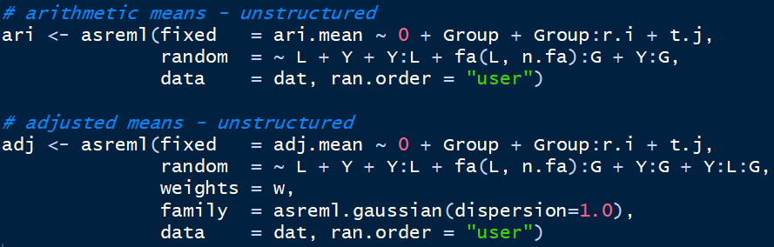

n.fa = 3 | Arithmetic means | Adjusted means
Aman | Not converged | Not converged
Boro | Not converged | Not converged

n.fa = 2 | Arithmetic means | Adjusted means
Aman | Not converged | Not converged
Boro | Not converged | Not converged

n.fa = 1 | Arithmetic means | Adjusted means
Aman | Not converged | Not converged
Boro | Converged | Converged

